Project Title

Password Strength Checker
Submitted by M. Ammar Khan

Project Overview
This project is a Password Strength Checker developed using Python and Tkinter. It checks whether a password is weak, medium, or strong based on security rules like length, uppercase letters, numbers, and symbols.
This project is part of the DecodeLabs Cyber Security Internship Program (Batch 2026).

Features
- Password strength checking
- Detects uppercase, lowercase, numbers, and symbols
- Show/Hide password option
- Color-based strength feedback
- Simple and user-friendly GUI

Technologies Used
- Python
- Tkinter

Password Strength Rules
- Weak: Less than 6 characters
- Medium: Contains letters and numbers
- Strong: Contains uppercase, numbers, symbols, and length 8 or more

How to Run
- Install Python
- Open terminal or command prompt
- Run the file using:
python main.py

Screenshots
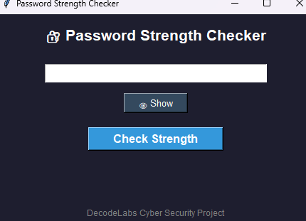
- Screenshot 1: Main Interface

- Screenshot 2: Weak Password Result
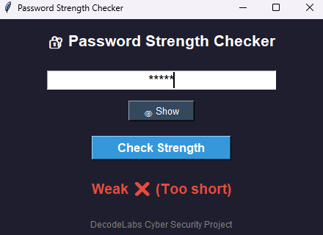

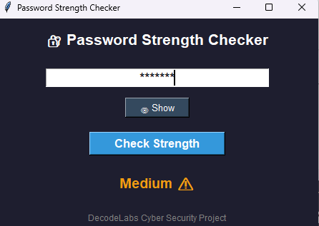
- Screenshot 3: Medium Password Result

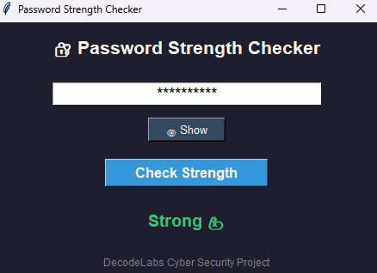
- Screenshot 4: Strong Password Result

Developer
Ammar Khan

Internship Program
DecodeLabs Cyber Security Program 2026

